EXPERIMENT 1
Title
Read an Image and Convert it to Grayscale
Aim
To read an image using Python and convert it into a grayscale image using OpenCV.
Procedure
- Import the OpenCV library (cv2).
- Read the input image using the cv2.imread() function.
- Check whether the image is loaded successfully.
- Convert the color image into a grayscale image using the cv2.cvtColor() function.
- Display both the original and grayscale images using cv2.imshow().
- Wait for a key press using cv2.waitKey(0).
- Close all the image windows using cv2.destroyAllWindows().
Program
import cv2

img = cv2.imread(r"C:\Users\mothi\Documents\00.png")

if img is None:
print("Error: Image not found!")
else:
gray = cv2.cvtColor(img, cv2.COLOR_BGR2GRAY)

cv2.imshow("Original Image", img)
cv2.imshow("Grayscale Image", gray)

cv2.waitKey(0)
cv2.destroyAllWindows()

Output:
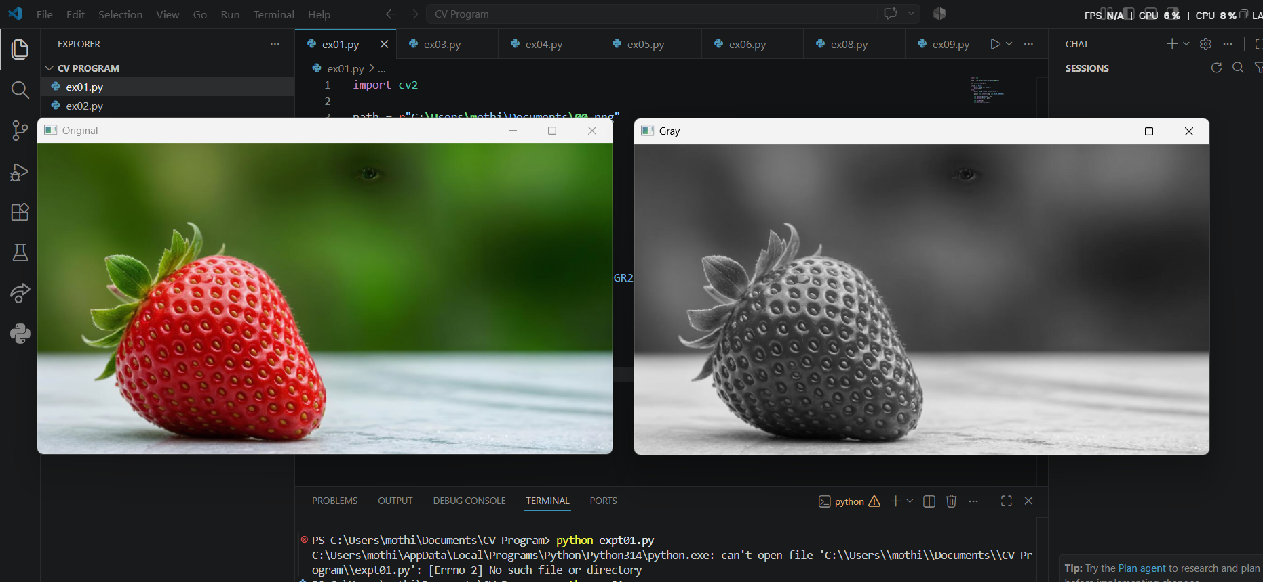
Result
The input image was successfully converted into a grayscale image.

EXPERIMENT 2
Title
Read an Image and Apply Gaussian Blur
Aim
To read an image and apply Gaussian Blur using the OpenCV GaussianBlur() function.
Procedure
- Import the OpenCV library.
- Read the input image using cv2.imread().
- Verify that the image is loaded correctly.
- Apply Gaussian Blur using cv2.GaussianBlur() with a suitable kernel size.
- Display both the original and blurred images.
- Wait for a key press.
- Close all display windows.
Program
import cv2

img = cv2.imread(r"C:\Users\mothi\Documents\00.png")

if img is None:
print("Error: Image not found!")
else:
blur = cv2.GaussianBlur(img, (7,7), 0)

cv2.imshow("Original Image", img)
cv2.imshow("Blurred Image", blur)

cv2.waitKey(0)
cv2.destroyAllWindows()
Output:
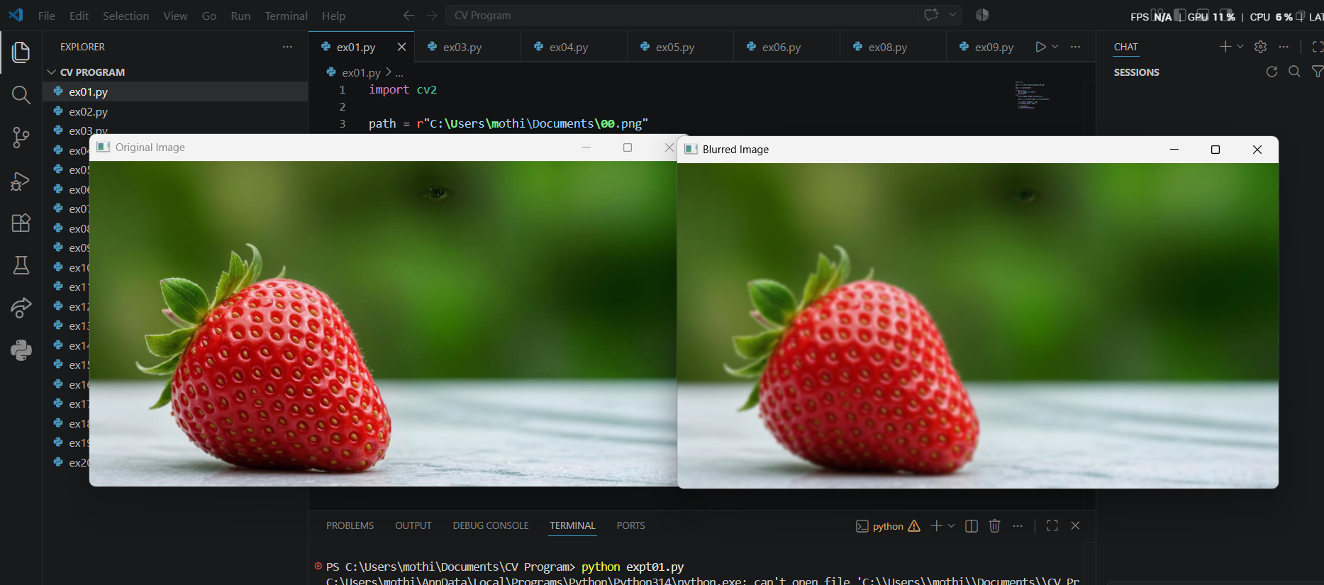
Result
The input image was successfully blurred using the Gaussian Blur filter.

EXPERIMENT 3
Title
Read an Image and Detect Edges using Canny Method
Aim
To detect the edges of an image using the Canny edge detection method.
Procedure
- Import the OpenCV library.
- Read the input image.
- Check whether the image is loaded successfully.
- Convert the image into grayscale.
- Apply the cv2.Canny() function with suitable threshold values.
- Display the original and edge-detected images.
- Close all windows after pressing any key.
Program
import cv2

img = cv2.imread(r"C:\Users\mothi\Documents\00.png")

if img is None:
print("Error: Image not found!")
else:
gray = cv2.cvtColor(img, cv2.COLOR_BGR2GRAY)

edges = cv2.Canny(gray, 100, 200)

cv2.imshow("Original Image", img)
cv2.imshow("Canny Edge Detection", edges)

cv2.waitKey(0)
cv2.destroyAllWindows()
Output:
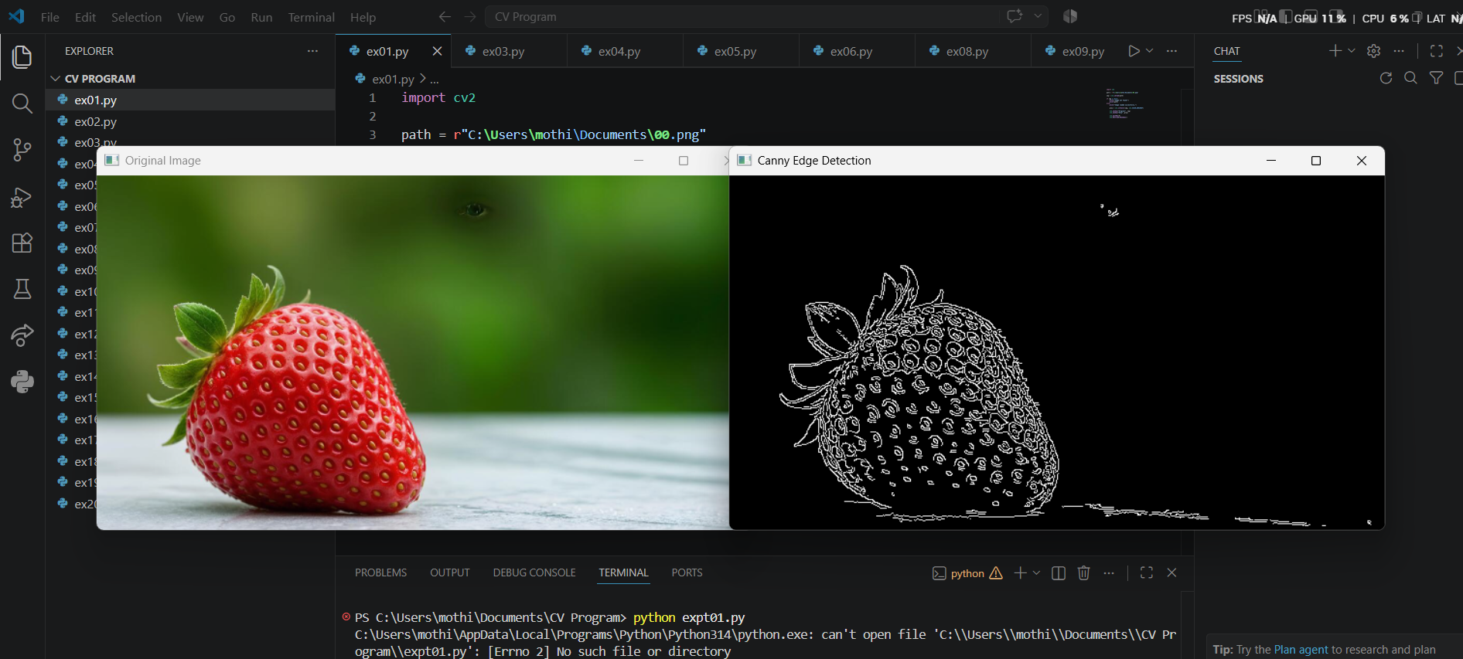
Result
The edges of the input image were successfully detected using the Canny edge detection method.

EXPERIMENT 4
Title
Perform Image Dilation using Dilate Function
Aim
To perform image dilation using the OpenCV dilate() function.
Procedure
- Import the OpenCV and NumPy libraries.
- Read the input image.
- Verify that the image is loaded successfully.
- Create a 5×5 kernel using NumPy.
- Apply the cv2.dilate() function to dilate the image.
- Display both the original and dilated images.
- Close all windows after pressing any key.
Program
import cv2
import numpy as np

img = cv2.imread(r"C:\Users\mothi\Documents\00.png")

if img is None:
print("Error: Image not found!")
else:
kernel = np.ones((5,5), np.uint8)

dilated = cv2.dilate(img, kernel, iterations=1)

cv2.imshow("Original Image", img)
cv2.imshow("Dilated Image", dilated)

cv2.waitKey(0)
cv2.destroyAllWindows()
Output:
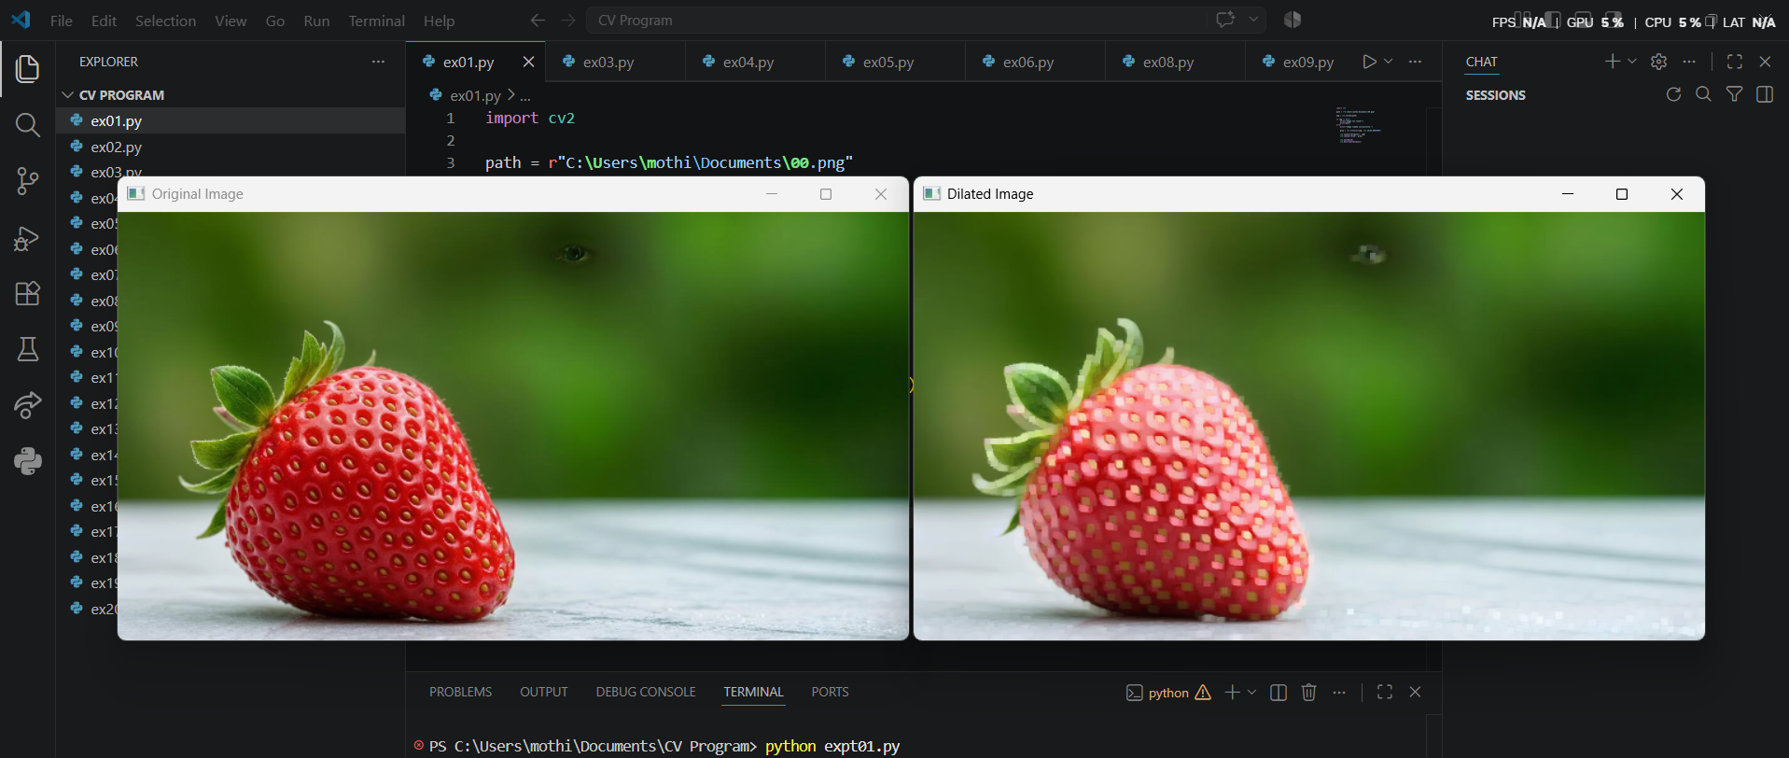
Result
The image was successfully dilated, increasing the thickness of object boundaries.

EXPERIMENT 5
Title
Perform Image Erosion using Erode Function
Aim
To perform image erosion using the OpenCV erode() function.
Procedure
- Import the OpenCV and NumPy libraries.
- Read the input image.
- Check whether the image is loaded successfully.
- Create a 5×5 kernel using NumPy.
- Apply the cv2.erode() function.
- Display both the original and eroded images.
- Close all windows after pressing any key.
Program
import cv2
import numpy as np

img = cv2.imread(r"C:\Users\mothi\Documents\00.png")

if img is None:
print("Error: Image not found!")
else:
kernel = np.ones((5,5), np.uint8)

eroded = cv2.erode(img, kernel, iterations=1)

cv2.imshow("Original Image", img)
cv2.imshow("Eroded Image", eroded)

cv2.waitKey(0)
cv2.destroyAllWindows()
Output:
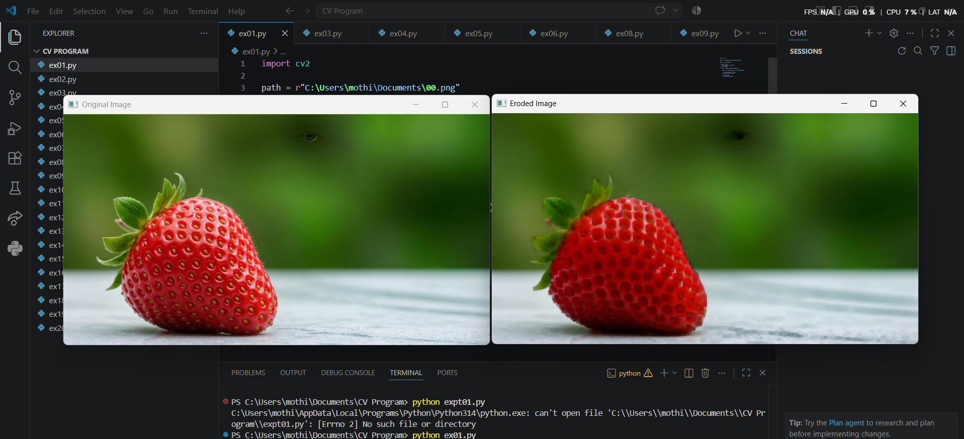
Result
The image was successfully eroded, reducing the thickness of object boundaries and removing small noise.

EXPERIMENT 6
Title
Read a Captured Video and Display the Video in Slow Motion and Fast Motion
Aim
To read a captured video using Python and display it in slow motion and fast motion using OpenCV.
Procedure
- Import the OpenCV library.
- Read the video file using the cv2.VideoCapture() function.
- Check whether the video file is opened successfully.
- Read the video frame by frame.
- Display each frame using cv2.imshow().
- Use cv2.waitKey(100) to display the video in slow motion.
- Change the delay to cv2.waitKey(10) to display the video in fast motion.
- Press 'q' to stop the video playback.
- Release the video object and close all windows.
Program
import cv2

cap = cv2.VideoCapture(r"C:\Users\mothi\Documents\video.mp4")

if not cap.isOpened():
print("Error: Unable to open video.")
else:
while True:
ret, frame = cap.read()

if not ret:
break

cv2.imshow("Video", frame)

# Slow Motion (Change 100 to 10 for Fast Motion)
if cv2.waitKey(100) & 0xFF == ord('q'):
break

cap.release()
cv2.destroyAllWindows()
Output:
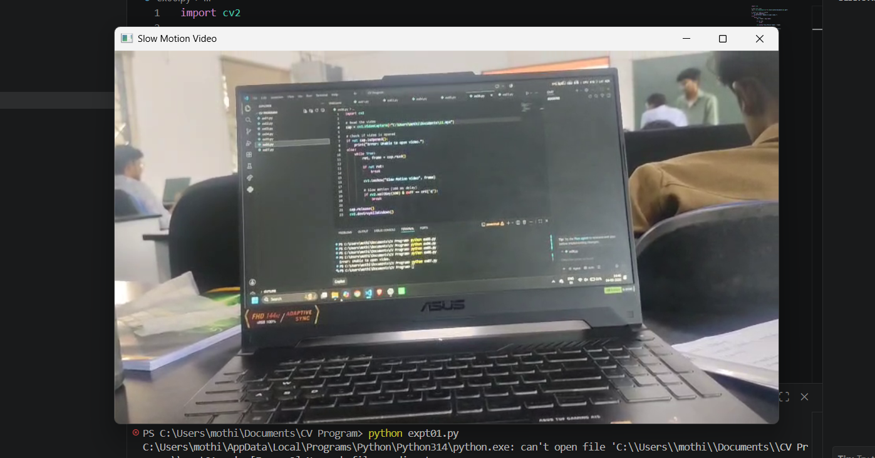
Result
The captured video was successfully displayed in slow motion and fast motion.

EXPERIMENT 7
Title
Capture Video from Web Camera and Display the Video in Slow Motion and Fast Motion
Aim
To capture video from the webcam and display it in slow motion and fast motion using OpenCV.
Procedure
- Import the OpenCV library.
- Access the webcam using cv2.VideoCapture(0).
- Verify that the webcam is opened successfully.
- Capture video frame by frame.
- Display each frame using cv2.imshow().
- Use cv2.waitKey(100) for slow motion.
- Use cv2.waitKey(10) for fast motion.
- Press 'q' to stop capturing.
- Release the webcam and close all windows.
Program
import cv2

cap = cv2.VideoCapture(0)

if not cap.isOpened():
print("Error: Webcam not detected.")
else:
while True:
ret, frame = cap.read()

if not ret:
break

cv2.imshow("Webcam", frame)

# Slow Motion (Change 100 to 10 for Fast Motion)
if cv2.waitKey(100) & 0xFF == ord('q'):
break

cap.release()
cv2.destroyAllWindows()
Output:
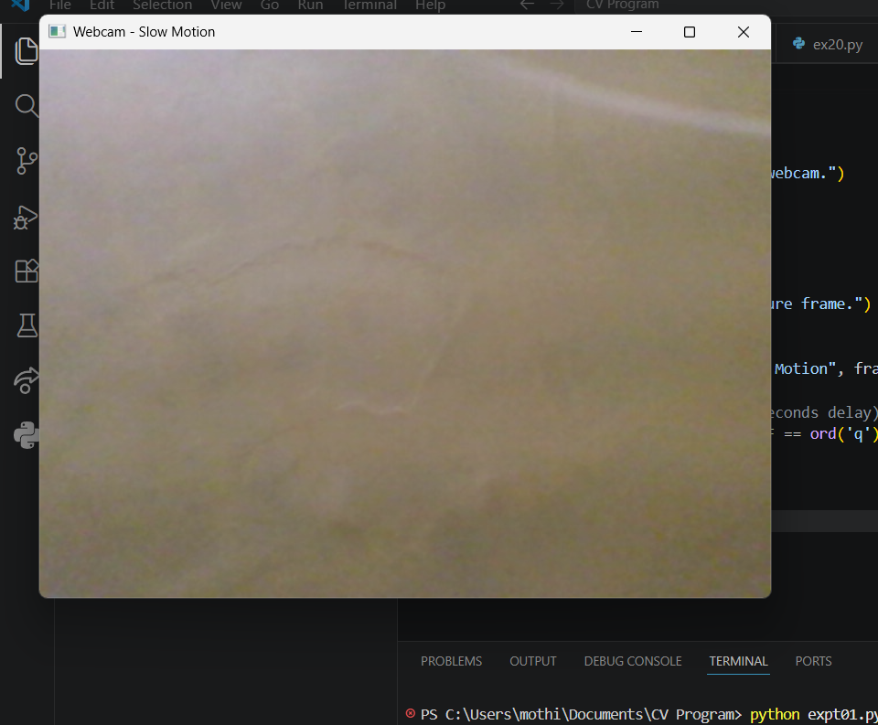
Result
The webcam video was successfully captured and displayed in slow motion and fast motion.

EXPERIMENT 8
Title
Scaling an Image to its Bigger and Smaller Sizes
Aim
To scale an image into bigger and smaller sizes using the OpenCV resize() function.
Procedure
- Import the OpenCV library.
- Read the input image using cv2.imread().
- Check whether the image is loaded successfully.
- Resize the image to a larger size using scaling factors greater than 1.
- Resize the image to a smaller size using scaling factors less than 1.
- Display the original, enlarged, and reduced images.
- Wait for a key press.
- Close all windows.
Program
import cv2

img = cv2.imread(r"C:\Users\mothi\Documents\00.png")

if img is None:
print("Error: Image not found!")
else:
bigger = cv2.resize(img, None, fx=2, fy=2, interpolation=cv2.INTER_LINEAR)

smaller = cv2.resize(img, None, fx=0.5, fy=0.5, interpolation=cv2.INTER_AREA)

cv2.imshow("Original Image", img)
cv2.imshow("Bigger Image", bigger)
cv2.imshow("Smaller Image", smaller)

cv2.waitKey(0)
cv2.destroyAllWindows()
Output:
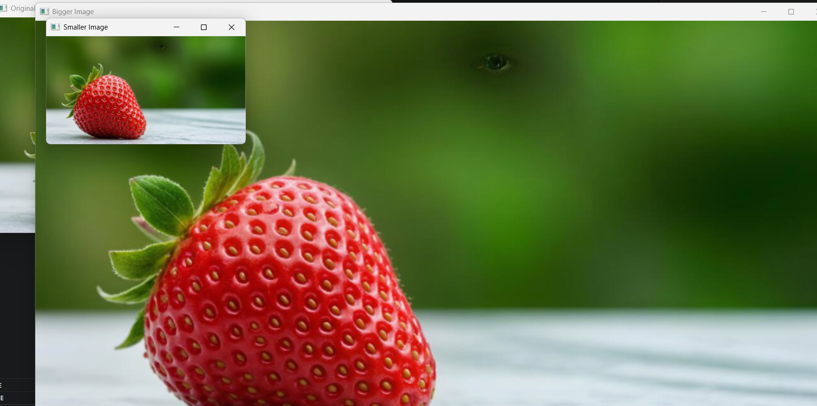
Result
The input image was successfully resized into bigger and smaller sizes.

EXPERIMENT 9
Title
Perform Rotation of an Image in Clockwise and Counter Clockwise Direction
Aim
To rotate an image in clockwise and counter-clockwise directions using OpenCV.
Procedure
- Import the OpenCV library.
- Read the input image.
- Find the center of the image.
- Create rotation matrices for clockwise and counter-clockwise rotations.
- Rotate the image using cv2.warpAffine().
- Display the rotated images.
- Wait for a key press.
- Close all display windows.
Program
import cv2

img = cv2.imread(r"C:\Users\mothi\Documents\00.png")

if img is None:
print("Error: Image not found!")
else:
(h, w) = img.shape[:2]
center = (w // 2, h // 2)

M1 = cv2.getRotationMatrix2D(center, -90, 1)

clockwise = cv2.warpAffine(img, M1, (w, h))

M2 = cv2.getRotationMatrix2D(center, 90, 1)

counter = cv2.warpAffine(img, M2, (w, h))

cv2.imshow("Original Image", img)
cv2.imshow("Clockwise Rotation", clockwise)
cv2.imshow("Counter Clockwise Rotation", counter)

cv2.waitKey(0)
cv2.destroyAllWindows()
Output:
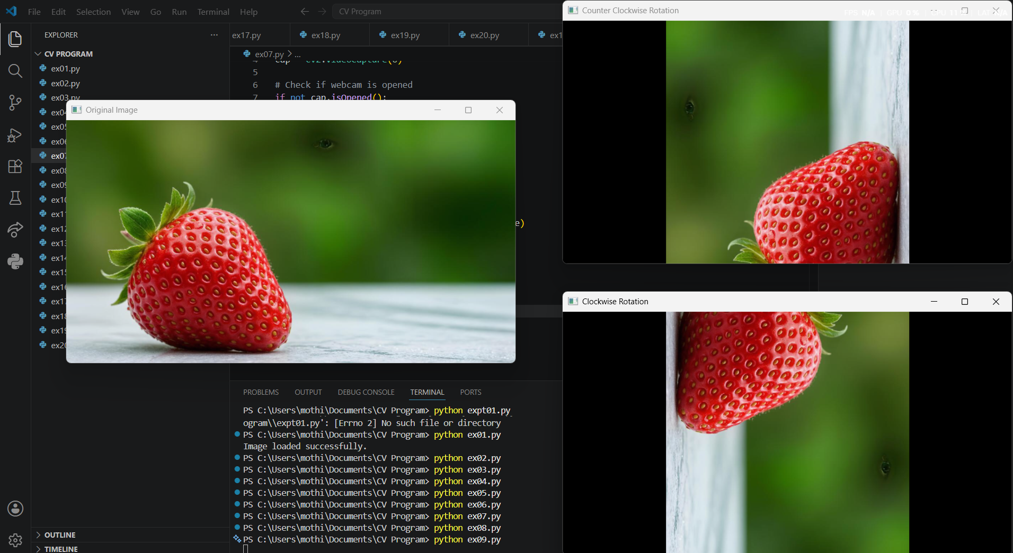
Result
The image was successfully rotated in clockwise and counter-clockwise directions.

EXPERIMENT 10
Title
Perform Moving (Translation) of an Image from One Place to Another
Aim
To translate an image from one position to another using OpenCV.
Procedure
- Import the OpenCV and NumPy libraries.
- Read the input image.
- Check whether the image is loaded correctly.
- Create a translation matrix.
- Apply the translation using cv2.warpAffine().
- Display the original and translated images.
- Wait for a key press.
- Close all windows.
Program
import cv2
import numpy as np

img = cv2.imread(r"C:\Users\mothi\Documents\00.png")

if img is None:
print("Error: Image not found!")
else:
rows, cols = img.shape[:2]

M = np.float32([[1, 0, 100],
[0, 1, 50]])

translated = cv2.warpAffine(img, M, (cols, rows))

cv2.imshow("Original Image", img)
cv2.imshow("Translated Image", translated)

cv2.waitKey(0)
cv2.destroyAllWindows()
Output:
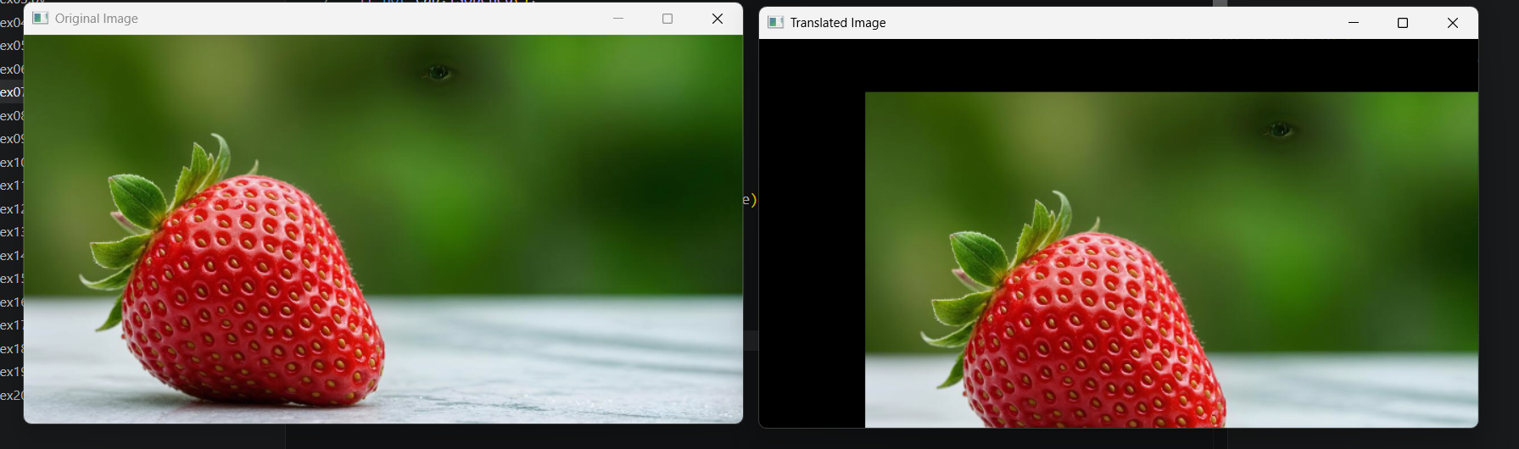
Result
The image was successfully translated from one position to another using the translation matrix.
EXPERIMENT 11
Title
Perform Affine Transformation on an Image
Aim
To perform affine transformation on an image using OpenCV.
Procedure
- Import the OpenCV and NumPy libraries.
- Read the input image using cv2.imread().
- Verify that the image is loaded successfully.
- Select three source points and three destination points.
- Compute the affine transformation matrix using cv2.getAffineTransform().
- Apply the transformation using cv2.warpAffine().
- Display the original and transformed images.
- Wait for a key press and close all windows.
Program
import cv2
import numpy as np

# Read the image
img = cv2.imread(r"C:\Users\mothi\Documents\00.png")

if img is None:
print("Error: Image not found!")
else:
rows, cols = img.shape[:2]

# Source points
pts1 = np.float32([[50, 50],
[200, 50],
[50, 200]])

# Destination points
pts2 = np.float32([[10, 100],
[200, 50],
[100, 250]])

# Affine transformation matrix
M = cv2.getAffineTransform(pts1, pts2)

# Apply transformation
affine = cv2.warpAffine(img, M, (cols, rows))

cv2.imshow("Original Image", img)
cv2.imshow("Affine Transformation", affine)

cv2.waitKey(0)
cv2.destroyAllWindows()

Output:
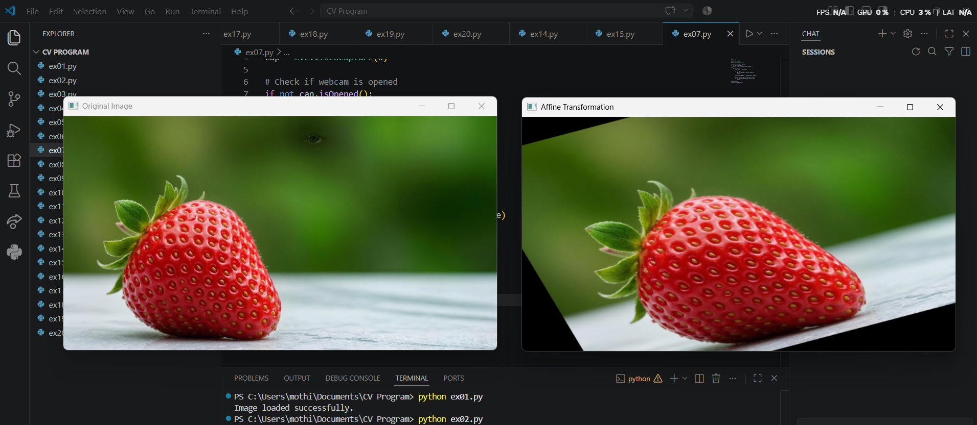
Result
The affine transformation was successfully performed on the input image.

EXPERIMENT 12
Title
Perform Perspective Transformation on an Image
Aim
To perform perspective transformation on an image using OpenCV.
Procedure
- Import the required libraries.
- Read the input image.
- Select four source and destination points.
- Calculate the perspective transformation matrix.
- Apply the transformation using cv2.warpPerspective().
- Display the transformed image.
- Close all windows.
Program
import cv2
import numpy as np

img = cv2.imread(r"C:\Users\mothi\Documents\00.png")

if img is None:
print("Error: Image not found!")
else:
pts1 = np.float32([[50,50],
[250,50],
[50,250],
[250,250]])

pts2 = np.float32([[0,0],
[300,0],
[0,300],
[300,300]])

M = cv2.getPerspectiveTransform(pts1, pts2)

result = cv2.warpPerspective(img, M, (300,300))

cv2.imshow("Original Image", img)
cv2.imshow("Perspective Transformation", result)

cv2.waitKey(0)
cv2.destroyAllWindows()
Output:

Result
The perspective transformation was successfully performed on the input image.

EXPERIMENT 13
Title
Perform Perspective Transformation on a Video
Aim
To perform perspective transformation on each frame of a video using OpenCV.
Procedure
- Import the required libraries.
- Open the video file using VideoCapture().
- Read each frame of the video.
- Compute the perspective transformation matrix.
- Apply the transformation to every frame.
- Display the transformed video.
- Press q to stop the video.
- Release the video and close all windows.
Program
import cv2
import numpy as np

cap = cv2.VideoCapture(r"C:\Users\mothi\Documents\video.mp4")

while True:

ret, frame = cap.read()

if not ret:
break

h, w = frame.shape[:2]

pts1 = np.float32([[50,50],
[w-50,50],
[50,h-50],
[w-50,h-50]])

pts2 = np.float32([[0,0],
[w,0],
[0,h],
[w,h]])

M = cv2.getPerspectiveTransform(pts1, pts2)

output = cv2.warpPerspective(frame, M, (w,h))

cv2.imshow("Perspective Video", output)

if cv2.waitKey(30) & 0xFF == ord('q'):
break

cap.release()
cv2.destroyAllWindows()
Output:

Result
Perspective transformation was successfully applied to the video frames.

EXPERIMENT 14
Title
Perform Transformation using Homography Matrix
Aim
To perform image transformation using a Homography matrix.
Procedure
- Import OpenCV and NumPy.
- Read the input image.
- Select four corresponding source and destination points.
- Calculate the Homography matrix using cv2.findHomography().
- Apply the transformation using cv2.warpPerspective().
- Display the transformed image.
- Close all windows.
Program
import cv2
import numpy as np

img = cv2.imread(r"C:\Users\mothi\Documents\00.png")

if img is None:
print("Error: Image not found!")
else:

src = np.float32([[50,50],
[250,50],
[50,250],
[250,250]])

dst = np.float32([[20,80],
[260,40],
[80,260],
[280,280]])

H, status = cv2.findHomography(src, dst)

output = cv2.warpPerspective(img, H, (300,300))

cv2.imshow("Original Image", img)
cv2.imshow("Homography Transformation", output)

cv2.waitKey(0)
cv2.destroyAllWindows()\
Output:
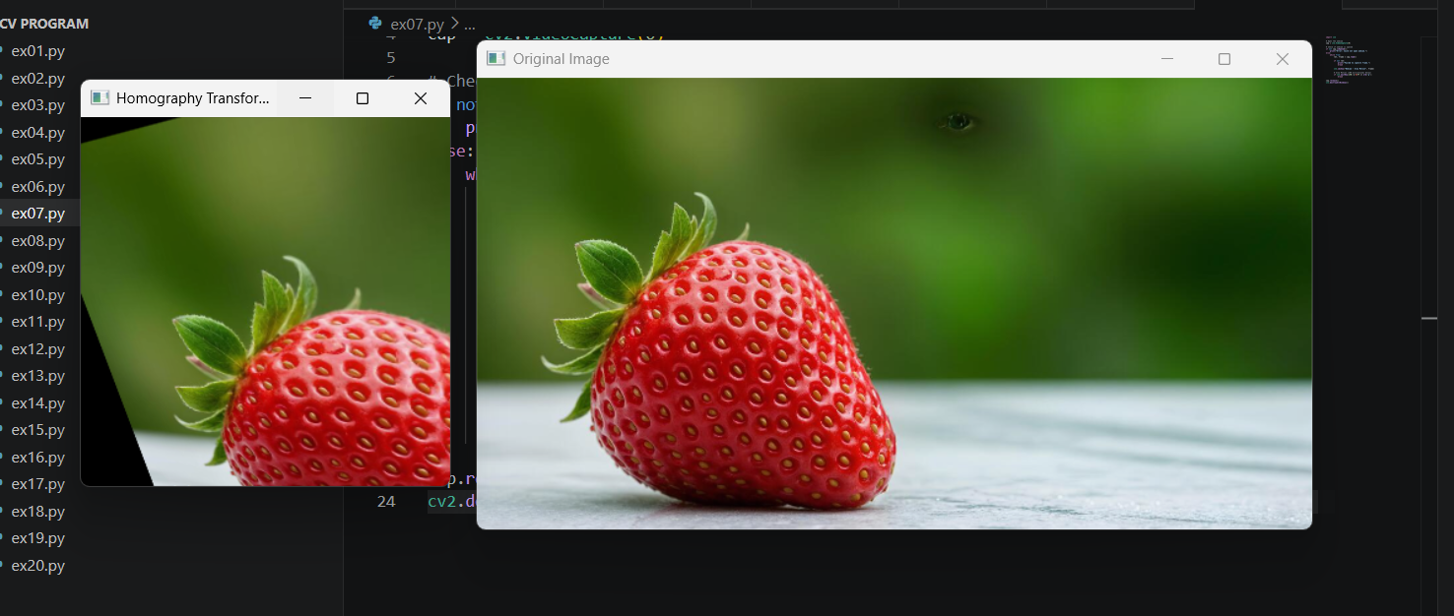
Result
The image was successfully transformed using the Homography matrix.

EXPERIMENT 15
Title
Perform Transformation using Direct Linear Transformation (DLT)
Aim
To perform image transformation using the Direct Linear Transformation (DLT) method.
Procedure
- Import OpenCV and NumPy libraries.
- Read the input image.
- Select corresponding source and destination points.
- Compute the Homography matrix using DLT.
- Apply the transformation using cv2.warpPerspective().
- Display the transformed image.
- Close all windows after a key press.
Program
import cv2
import numpy as np

img = cv2.imread(r"C:\Users\mothi\Documents\00.png")

if img is None:
print("Error: Image not found!")
else:

src = np.float32([[50,50],
[250,50],
[50,250],
[250,250]])

dst = np.float32([[0,0],
[300,0],
[50,300],
[300,300]])

H, status = cv2.findHomography(src, dst)

result = cv2.warpPerspective(img, H, (300,300))

cv2.imshow("Original Image", img)
cv2.imshow("DLT Transformation", result)

cv2.waitKey(0)
cv2.destroyAllWindows()
Output:
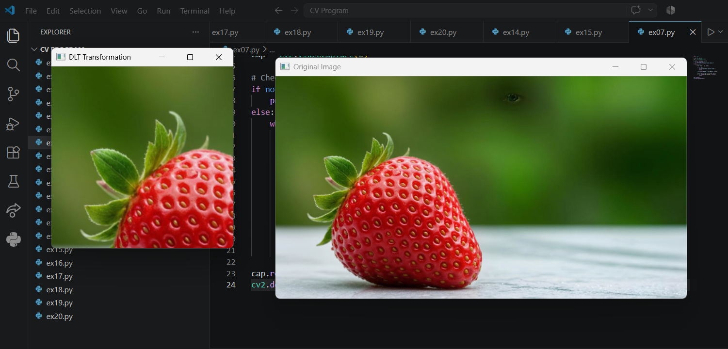
Result
The Direct Linear Transformation (DLT) was successfully performed on the input image using the Homography matrix.
EXPERIMENT 16
Title
Perform Edge Detection using Canny Method
Aim
To detect the edges of an image using the Canny edge detection method in OpenCV.
Procedure
- Import the OpenCV library.
- Read the input image using cv2.imread().
- Check whether the image is loaded successfully.
- Convert the image into grayscale using cv2.cvtColor().
- Apply the cv2.Canny() function with suitable threshold values.
- Display the original image and the edge-detected image.
- Wait for a key press and close all display windows.
Program
import cv2

# Read the image
img = cv2.imread(r"C:\Users\mothi\Documents\00.png")

if img is None:
print("Error: Image not found!")
else:
# Convert image to grayscale
gray = cv2.cvtColor(img, cv2.COLOR_BGR2GRAY)

# Apply Canny edge detection
edges = cv2.Canny(gray, 100, 200)

# Display images
cv2.imshow("Original Image", img)
cv2.imshow("Canny Edge Detection", edges)

cv2.waitKey(0)
cv2.destroyAllWindows()
Output:
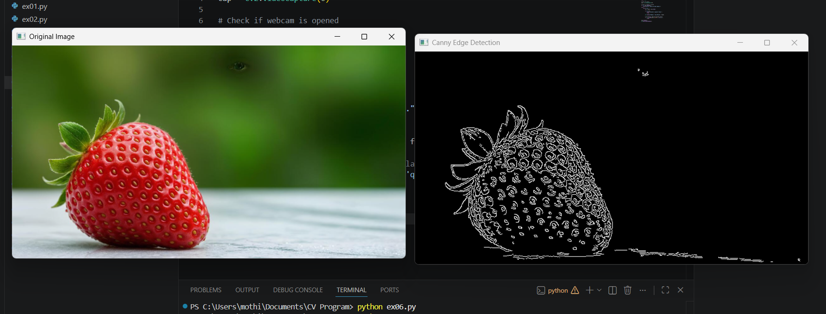
Result
The edges of the input image were successfully detected using the Canny edge detection method.

EXPERIMENT 17
Title
Perform Edge Detection using Sobel Matrix along X-axis
Aim
To detect horizontal edges of an image using the Sobel operator along the X-axis.
Procedure
- Import the OpenCV library.
- Read the input image.
- Convert the image into grayscale.
- Apply the Sobel X operator.
- Display the original and processed images.
- Wait for a key press.
- Close all display windows.
Program
import cv2

# Read the image
img = cv2.imread(r"C:\Users\mothi\Documents\00.png")

if img is None:
print("Error: Image not found!")
else:
gray = cv2.cvtColor(img, cv2.COLOR_BGR2GRAY)

# Sobel along X-axis
sobelx = cv2.Sobel(gray, cv2.CV_64F, 1, 0, ksize=3)

cv2.imshow("Original Image", img)
cv2.imshow("Sobel X", sobelx)

cv2.waitKey(0)
cv2.destroyAllWindows()
Output:
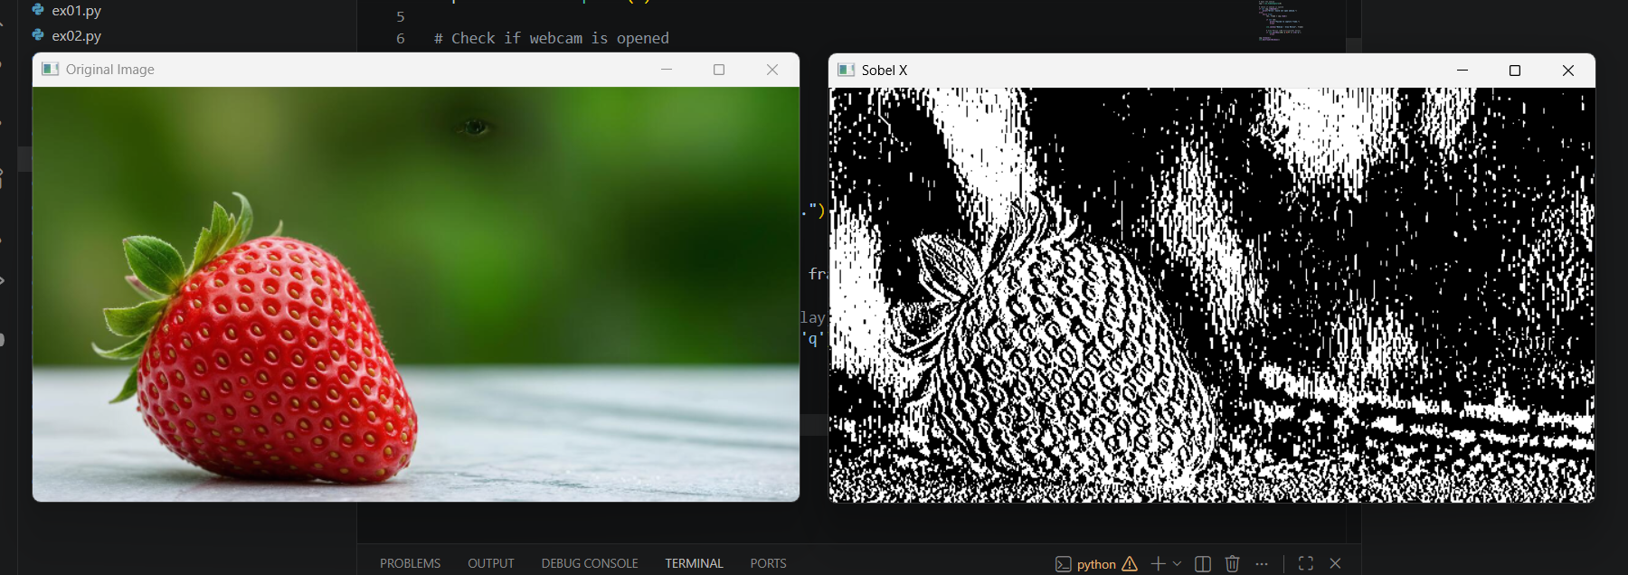
Result
The horizontal edges of the image were successfully detected using the Sobel X operator.

EXPERIMENT 18
Title
Perform Edge Detection using Sobel Matrix along Y-axis
Aim
To detect vertical edges of an image using the Sobel operator along the Y-axis.
Procedure
- Import the OpenCV library.
- Read the input image.
- Convert the image into grayscale.
- Apply the Sobel Y operator.
- Display the original and processed images.
- Wait for a key press.
- Close all display windows.
Program
import cv2

# Read the image
img = cv2.imread(r"C:\Users\mothi\Documents\00.png")

if img is None:
print("Error: Image not found!")
else:
gray = cv2.cvtColor(img, cv2.COLOR_BGR2GRAY)

# Sobel along Y-axis
sobely = cv2.Sobel(gray, cv2.CV_64F, 0, 1, ksize=3)

cv2.imshow("Original Image", img)
cv2.imshow("Sobel Y", sobely)

cv2.waitKey(0)
cv2.destroyAllWindows()
Output:
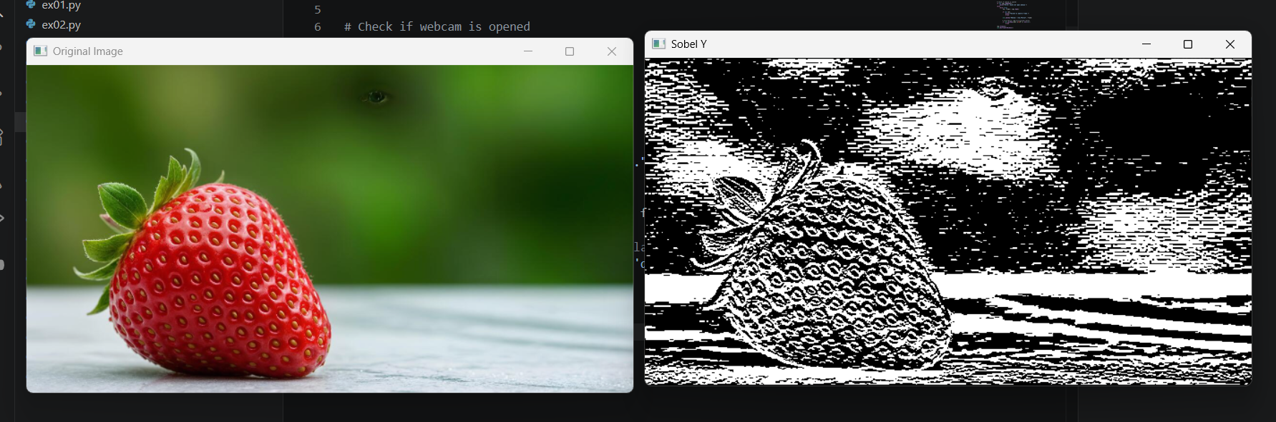
Result
The vertical edges of the image were successfully detected using the Sobel Y operator.

EXPERIMENT 19
Title
Perform Edge Detection using Sobel Matrix along X and Y Axes
Aim
To detect edges of an image using the Sobel operator along both the X-axis and Y-axis.
Procedure
- Import the OpenCV library.
- Read the input image.
- Convert the image into grayscale.
- Apply the Sobel operator along the X-axis.
- Apply the Sobel operator along the Y-axis.
- Combine both edge images.
- Display the original image and the combined edge image.
- Wait for a key press and close all display windows.
Program
import cv2

# Read the image
img = cv2.imread(r"C:\Users\mothi\Documents\00.png")

if img is None:
print("Error: Image not found!")
else:
gray = cv2.cvtColor(img, cv2.COLOR_BGR2GRAY)

sobelx = cv2.Sobel(gray, cv2.CV_64F, 1, 0, ksize=3)
sobely = cv2.Sobel(gray, cv2.CV_64F, 0, 1, ksize=3)

# Combine X and Y edges
sobelxy = cv2.addWeighted(sobelx, 0.5, sobely, 0.5, 0)

cv2.imshow("Original Image", img)
cv2.imshow("Sobel XY", sobelxy)

cv2.waitKey(0)
cv2.destroyAllWindows()
Output:
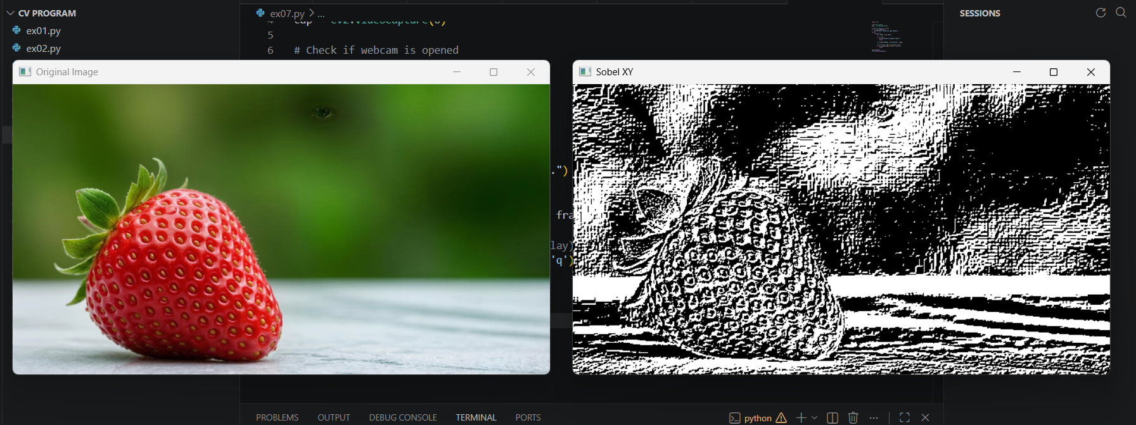
Result
The edges of the image were successfully detected using the Sobel operator along both the X-axis and Y-axis.

EXPERIMENT 20
Title
Perform Sharpening of an Image using Laplacian Mask with Negative Center Coefficient
Aim
To sharpen an image using a Laplacian mask with a negative center coefficient.
Procedure
- Import the OpenCV and NumPy libraries.
- Read the input image using cv2.imread().
- Check whether the image is loaded successfully.
- Create a Laplacian sharpening kernel with a negative center coefficient.
- Apply the kernel using the cv2.filter2D() function.
- Display the original image and the sharpened image.
- Wait for a key press and close all display windows.
Program
import cv2
import numpy as np

# Read the image
img = cv2.imread(r"C:\Users\mothi\Documents\00.png")

if img is None:
print("Error: Image not found!")
else:
# Laplacian sharpening kernel (negative center coefficient)
kernel = np.array([[0, 1, 0],
[1, -4, 1],
[0, 1, 0]])

# Apply the filter
sharpened = cv2.filter2D(img, -1, kernel)

cv2.imshow("Original Image", img)
cv2.imshow("Sharpened Image", sharpened)

cv2.waitKey(0)
cv2.destroyAllWindows()

Output:
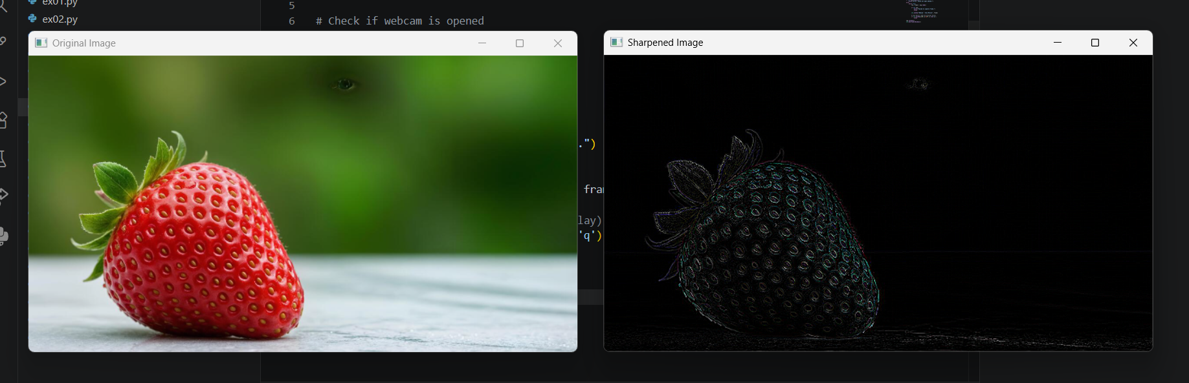
Result
The input image was successfully sharpened using the Laplacian mask with a negative center coefficient, resulting in enhanced edge details.

EXPERIMENT 21
Title
Perform Sharpening of Image using Laplacian Mask Implemented with an Extension of Diagonal Neighbors
Aim
To sharpen an image using a Laplacian mask with diagonal neighbors in OpenCV.

Procedure
- Import the required libraries such as OpenCV and NumPy.
- Read the input image using cv2.imread().
- Check whether the image is loaded successfully.
- Create the Laplacian mask with diagonal neighbors.
- Apply the mask using the cv2.filter2D() function.
- Display the original image and the sharpened image.
- Wait for a key press and close all display windows.

Program
import cv2
import numpy as np

# Read the image
img = cv2.imread(r"C:\Users\mothi\Documents\00.png")

if img is None:
print("Error: Image not found!")
else:
# Laplacian mask with diagonal neighbors
kernel = np.array([[1, 1, 1],
[1, -8, 1],
[1, 1, 1]])

# Apply filter
sharpened = cv2.filter2D(img, -1, kernel)

# Display images
cv2.imshow("Original Image", img)
cv2.imshow("Sharpened Image", sharpened)

cv2.waitKey(0)
cv2.destroyAllWindows()
Output:
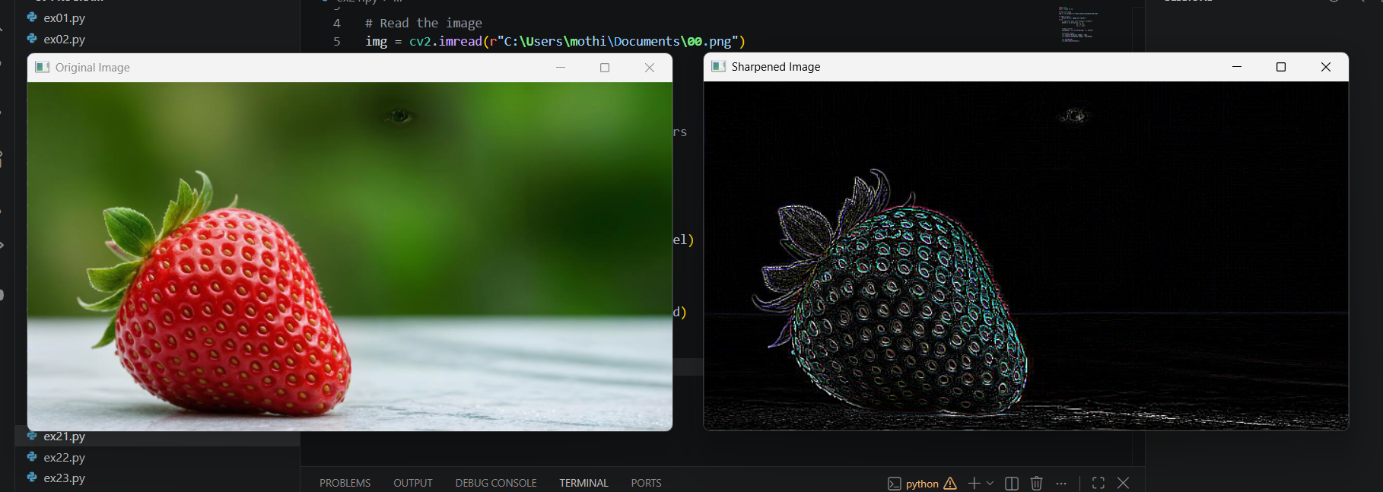
Result
The image was successfully sharpened using the Laplacian mask with diagonal neighbors.

EXPERIMENT 22
Title
Perform Sharpening of Image using Laplacian Mask with Positive Center Coefficient
Aim
To sharpen an image using a Laplacian mask with a positive center coefficient in OpenCV.

Procedure
- Import the required libraries such as OpenCV and NumPy.
- Read the input image using cv2.imread().
- Verify that the image is loaded successfully.
- Create the Laplacian mask with a positive center coefficient.
- Apply the mask using the cv2.filter2D() function.
- Display the original image and the sharpened image.
- Wait for a key press and close all display windows.

Program
import cv2
import numpy as np

# Read the image
img = cv2.imread(r"C:\Users\mothi\Documents\00.png")

if img is None:
print("Error: Image not found!")
else:
# Laplacian mask with positive center coefficient
kernel = np.array([[0, -1, 0],
[-1, 5, -1],
[0, -1, 0]])

# Apply filter
sharpened = cv2.filter2D(img, -1, kernel)

# Display images
cv2.imshow("Original Image", img)
cv2.imshow("Sharpened Image", sharpened)

cv2.waitKey(0)
cv2.destroyAllWindows()
Output:
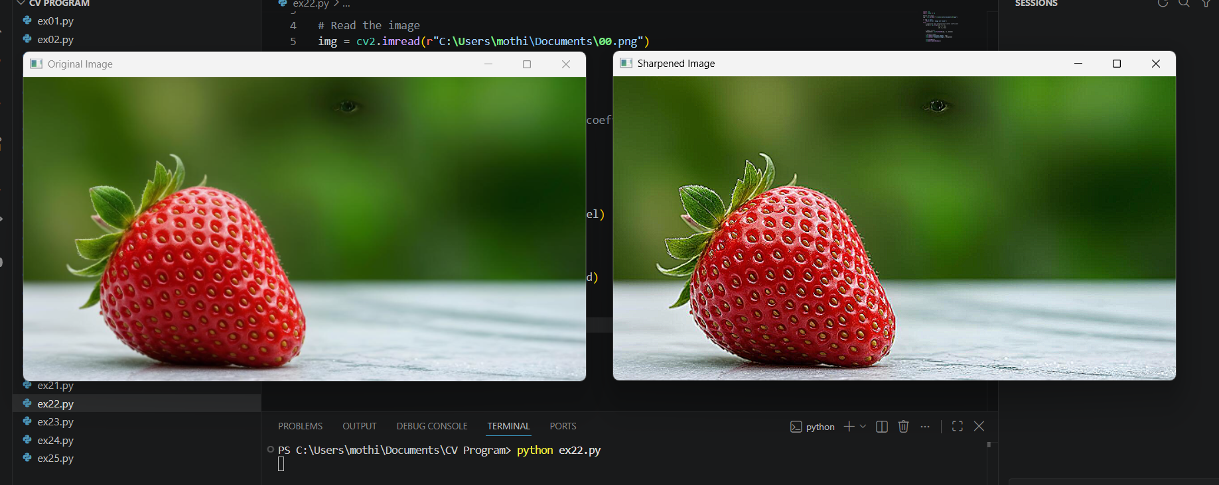
Result
The image was successfully sharpened using the Laplacian mask with a positive center coefficient, resulting in enhanced image details and sharper edges.

Title
Perform Sharpening of an Image using Unsharp Masking

Aim
To sharpen an image using the Unsharp Masking technique in OpenCV.

Procedure
- Import the required libraries such as OpenCV and NumPy.
- Read the input image using cv2.imread().
- Verify that the image is loaded successfully.
- Apply Gaussian Blur to obtain a blurred version of the image.
- Generate the unsharp mask by subtracting the blurred image from the original image.
- Add the unsharp mask to the original image to obtain the sharpened image.
- Display the original image, blurred image, and sharpened image.
- Wait for a key press and close all display windows.

Program
import cv2

# Read the image
img = cv2.imread(r"C:\Users\mothi\Documents\00.png")

if img is None:
print("Error: Image not found!")
else:
# Create a blurred image
blurred = cv2.GaussianBlur(img, (9, 9), 10.0)

# Perform unsharp masking
sharpened = cv2.addWeighted(img, 1.5, blurred, -0.5, 0)

# Display images
cv2.imshow("Original Image", img)
cv2.imshow("Blurred Image", blurred)
cv2.imshow("Sharpened Image", sharpened)

cv2.waitKey(0)
cv2.destroyAllWindows()
Output:
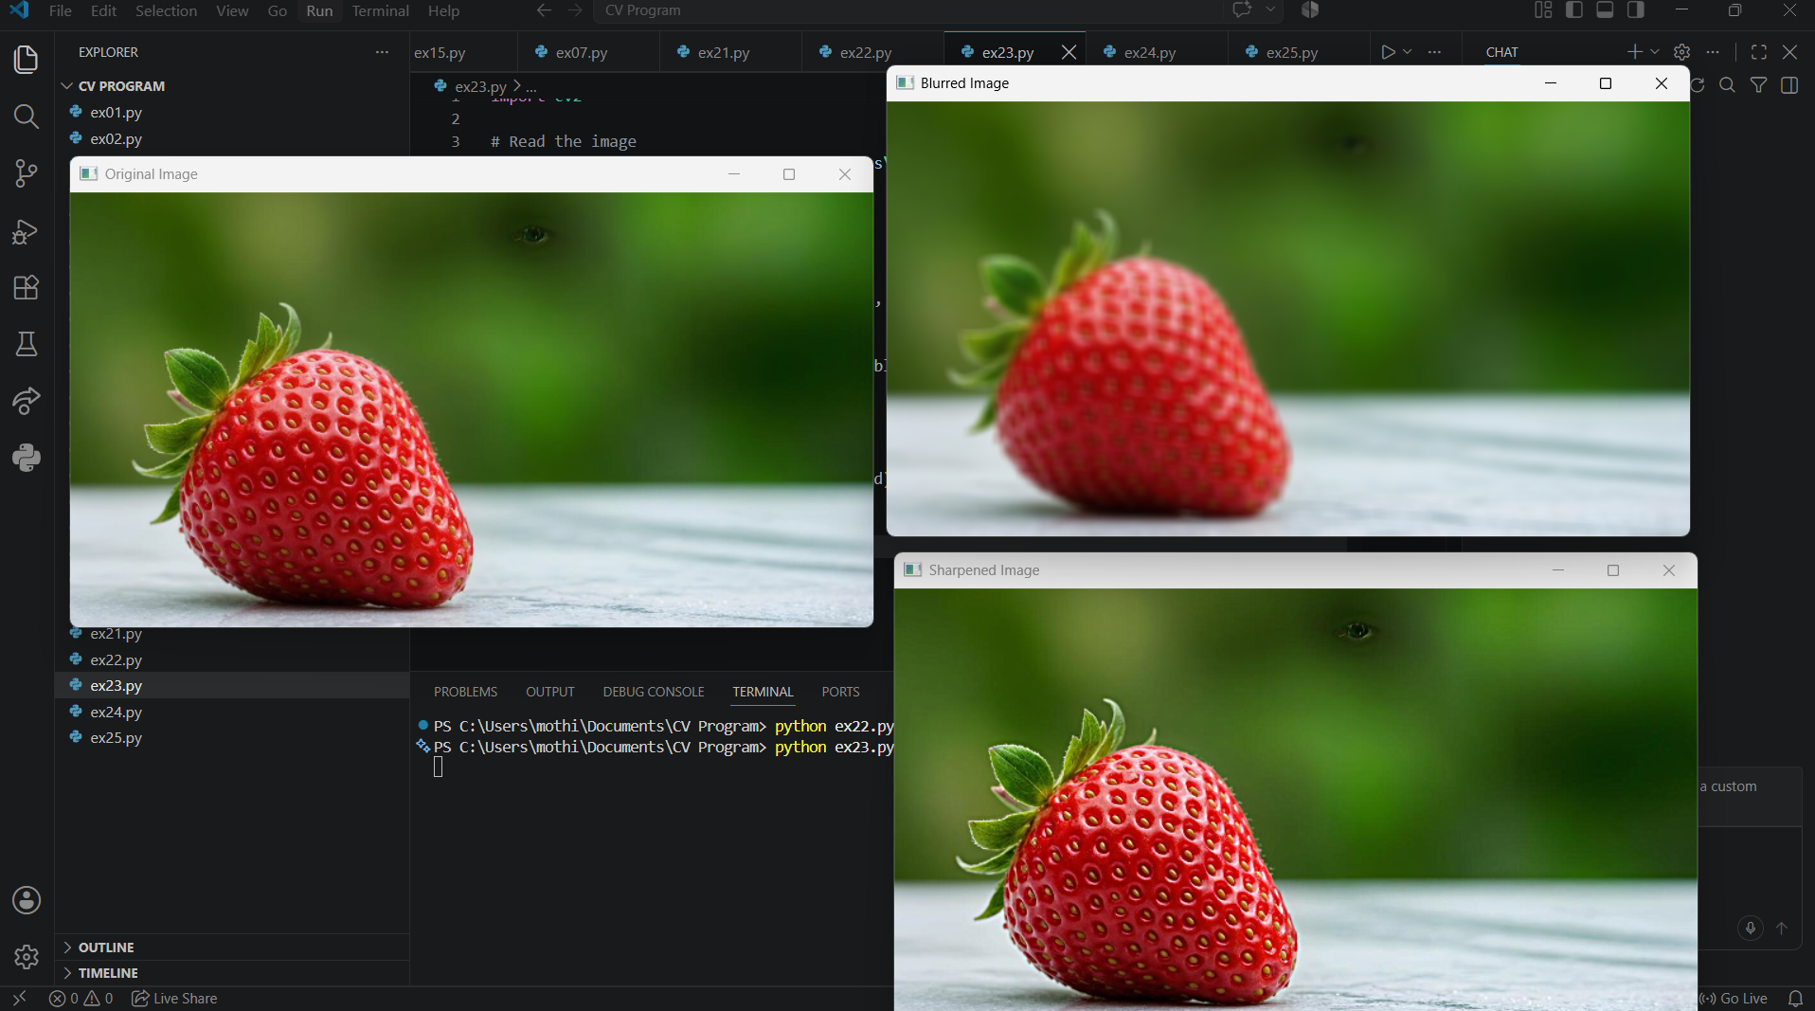
Result
The image was successfully sharpened using the Unsharp Masking technique. The sharpened image has improved edge clarity and enhanced fine details compared to the original image.
EXPERIMENT 24
Title
Perform Sharpening of an Image using High-Boost Masks
Aim
To sharpen an image using the High-Boost Mask technique in OpenCV.
Procedure
- Import the required libraries such as OpenCV and NumPy.
- Read the input image using cv2.imread().
- Check whether the image is loaded successfully.
- Create a High-Boost sharpening kernel.
- Apply the kernel using the cv2.filter2D() function.
- Display the original image and the sharpened image.
- Wait for a key press and close all display windows.
Program
import cv2
import numpy as np

# Read the image
img = cv2.imread(r"C:\Users\mothi\Documents\00.png")

if img is None:
print("Error: Image not found!")
else:
# High-Boost Mask (A = 1)
kernel = np.array([[0, -1, 0],
[-1, 5, -1],
[0, -1, 0]])

# Apply High-Boost filter
sharpened = cv2.filter2D(img, -1, kernel)

# Display images
cv2.imshow("Original Image", img)
cv2.imshow("High-Boost Sharpened Image", sharpened)

cv2.waitKey(0)
cv2.destroyAllWindows()
Output:
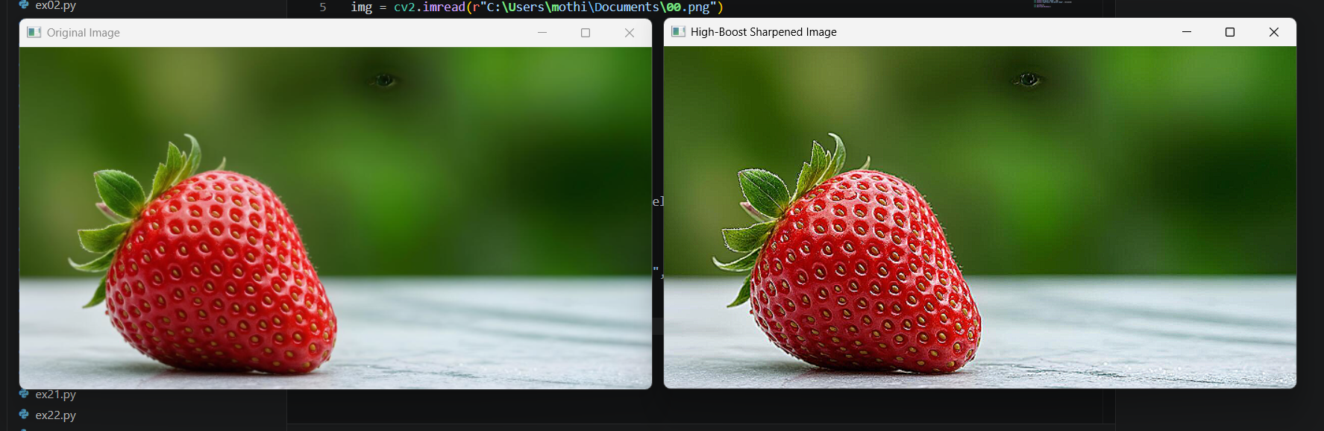
Result
The image was successfully sharpened using the High-Boost Mask technique, resulting in enhanced edges and improved image details.

EXPERIMENT 25
Title
Perform Sharpening of an Image using Gradient Masking
Aim
To sharpen an image using the Gradient Masking technique in OpenCV.
Procedure
- Import the required libraries such as OpenCV and NumPy.
- Read the input image using cv2.imread().
- Verify that the image is loaded successfully.
- Convert the image into grayscale.
- Apply Sobel operators along the X-axis and Y-axis to compute the gradient.
- Combine the gradient images to obtain the final gradient mask.
- Display the original image and the gradient image.
- Wait for a key press and close all display windows.
Program
import cv2
import numpy as np

# Read the image
img = cv2.imread(r"C:\Users\mothi\Documents\00.png")

if img is None:
print("Error: Image not found!")
else:
# Convert to grayscale
gray = cv2.cvtColor(img, cv2.COLOR_BGR2GRAY)

# Gradient using Sobel operators
grad_x = cv2.Sobel(gray, cv2.CV_64F, 1, 0, ksize=3)
grad_y = cv2.Sobel(gray, cv2.CV_64F, 0, 1, ksize=3)

# Combine gradients
gradient = cv2.magnitude(grad_x, grad_y)

# Convert to displayable format
gradient = cv2.convertScaleAbs(gradient)

# Display images
cv2.imshow("Original Image", img)
cv2.imshow("Gradient Mask Image", gradient)

cv2.waitKey(0)
cv2.destroyAllWindows()
Output:
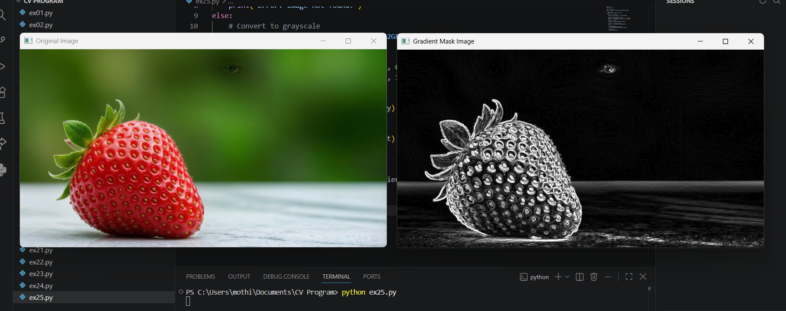
Result
The image was successfully processed using the Gradient Masking technique, highlighting edges and enhancing the sharpness of the image.

